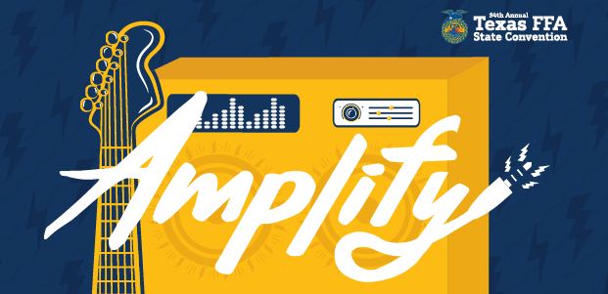
94th Texas FFA Convention
Location: Fort Worth, Texas (Fort Worth Convention Center)
All FFA Events will take place at the Fort Worth Convention Center unless otherwise noted.
All events could change at Ag Teachers discretion.

Monday, July 11
- Dress: Travel Clothes (Dress Code)
- Meet at the Ag Shop at 7:00am. Have paperwork signed and turned in.
- Leave by TBA. Head to Ft. Worth to watch Logan, Slade and Brayden compete in the FFA Rodeo.
- Check in to Hotel after the rodeo
    - Home2 Suites
1145 University Dr.
Fort Worth, Tx 76107

Tuesday, July 12
- Dress: Comfy Clothes (Dress Code)
- 8:00am to 5:00pm- Chapter Registration
- 2:00pm- FINALS Short Round FFA Rodeo
- 5:00 pm - Eat Supper
- 7:00pm to 8:00pm- Kick off Concert- Mike Ryan

Wednesday, July 13
- Dress: ALL WEAR OFFICIAL DRESS
- 8:15am- Second Pre-Session
- 9:00am- Second General Session
- 11:30am- Feedlot opens
- 1:15pm- Lone Star Degree Pre-Session
- 2:00pm- Lone Star Degree
- 7:00pm- Tentative: Texas Rangers Game

Thursday, July 14
- Dress: ALL WEAR OFFICIAL DRESS
- 8:15am- Third Pre-Session
- 9:00am- Third General Session
- 11:30am- Feedlot opens
- 1:15pm- Forth Pre-Session
- 2:00pm- Forth General Session
- 6:45pm to 7:30pm- Fun Night: Travel Through Time: Dress in 1980’s styles!

Friday, July 15
- Dress: ALL WEAR OFFICIAL DRESS
- 8:15am- Mike Rowe- Pre-Session
- 9:00am- Mike Rowe Event
- 10:06am- Fifth Pre-Session
- 10:30am- Fifth General Session
- Return home around 3:00pm.

Things to remember:
- Casual dress definition:
Jeans with no holes. Shorts are ok as long as they are not the athletic type or jorts. Polo type shirts, button down shirts or FFA t-shirts are always good!
No athletic type shorts or jorts are to be worn except at the hotel!
Only shoes, boots or athletic shoes. No Crocs or slides!
- Fun Night theme for Area VIII is dress like the 1980’s so bring those clothing items with you if you are going to dress up!
- Meals will be covered by the school, however, be sure to bring enough money for souvenirs and snacks-this can range from 100 to 200 dollars depending on your spending habits

Official Dress should look like the photo below. Skirts must reach your knees or below. Black boots are acceptable. Shoes with white soles are not. Please adhere to this guideline as all of you will be voting delegates and you will not be allowed on the floor without proper official dress.
